1. First, we setup XAMPP which is a set of integrated Apache, PHP, MariaDB suite of programs that allow users to very simple to set up PHP + MySQL web server on their own computers. And we will start Apache and MySql.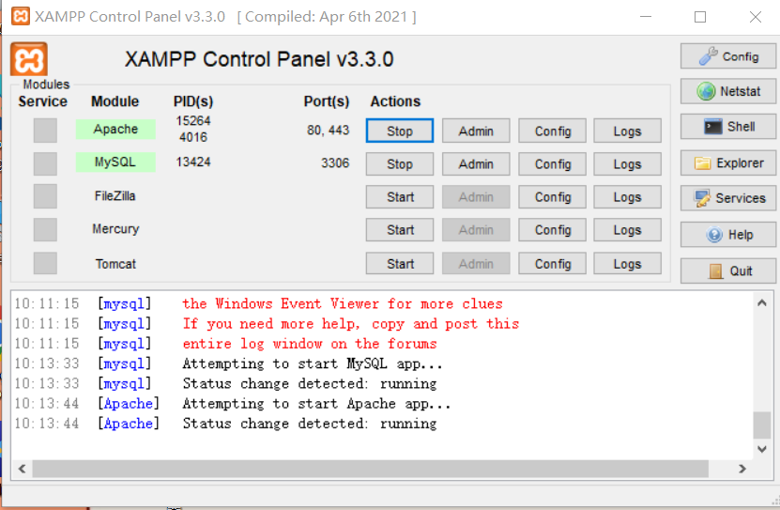
2. Build the shop_db database using phpMyAdmin and add the cart, orders, and product tables to it.

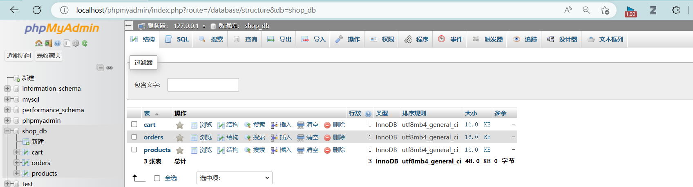

1. 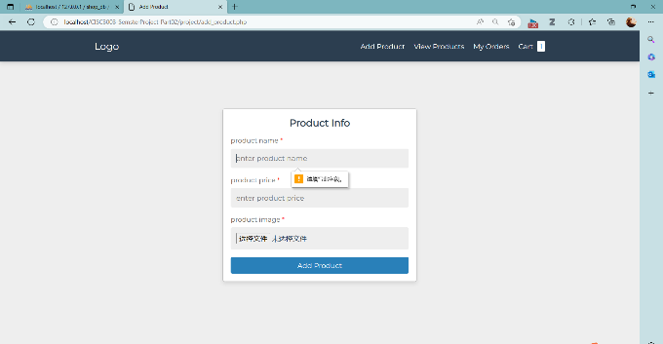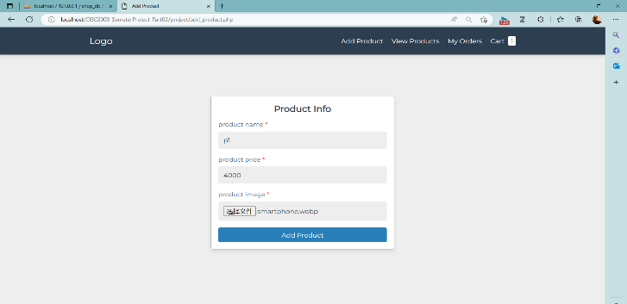Through the add product page, users can add product information by themselves, users need to input product name, product priced and product image, and then click the add product button to add the product information to the product list, meanwhile, the information entered by the user will be recorded in the database. If the user does not fill in the information completely, the form cannot be submitted and a message will pop up asking the user to complete the information.
2. Through the view product page, customers can see all the products and the specific information of each product and they can perform some operations. Customers can adjust the number of products they want by clicking on the button. When the user clicks on the blue add to cart button below the product will be added to the cart; when the user clicks on the red buy now button, it will jump to the checkout summary interface.

In the checkout summary page, users need to fill in the billing details form, if they finish filling in the form, they can click the place order button below to submit. As mentioned earlier, the form needs to be filled out completely. The email field must be a string with @ in it, if the user does not fill in the correct email format the form will not be submitted successfully and a message will pop up after clicking the submit button.

If the user successfully completes and submits the order, the user will be redirected to the My orders interface and the information will be recorded in the orders table in the database.

Whenever a new record is inserted into the order table of the database, in addition to the information filled in by the user, the database will also generate a current date, which is used to record the generation time of the user's order. This time is stored in the database as an attribute's value and will be displayed in the upper left corner of each order in the subsequent My order page.

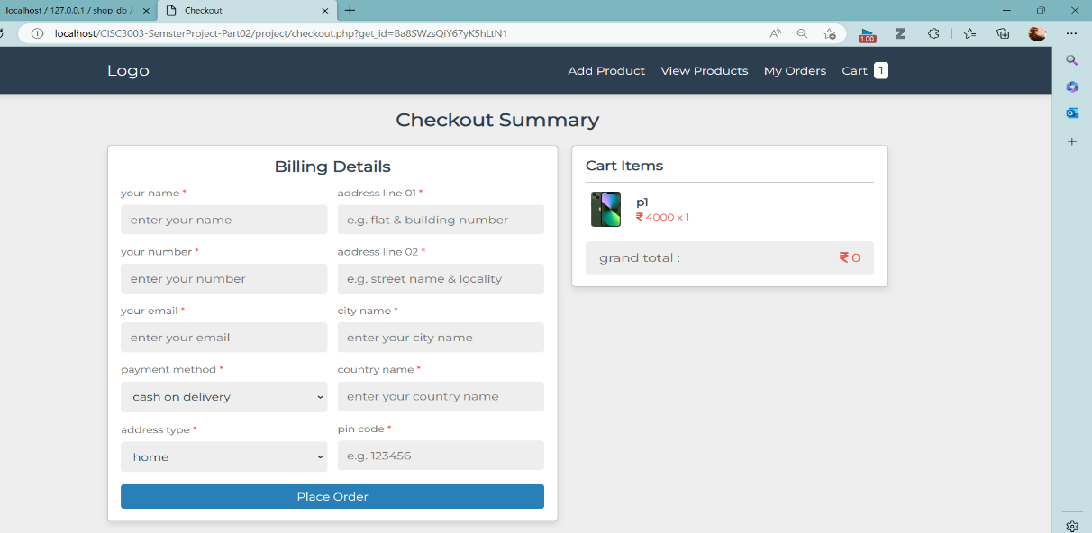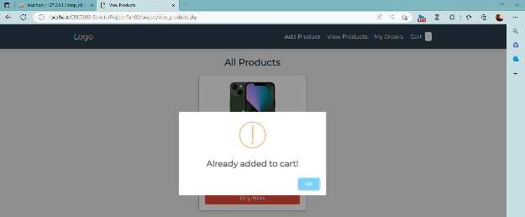

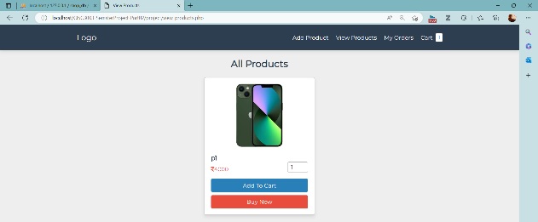

1. The My order screen displays all of the user's orders, and when the user clicks on the display box for each order, the user will be redirected to the Order Details screen, which records the details of the order that the user has entered, including the order creation time, the order price, and the building address.

If the user clicks the cancel order button, the order will be deleted and the information in the database will be synchronized and deleted.

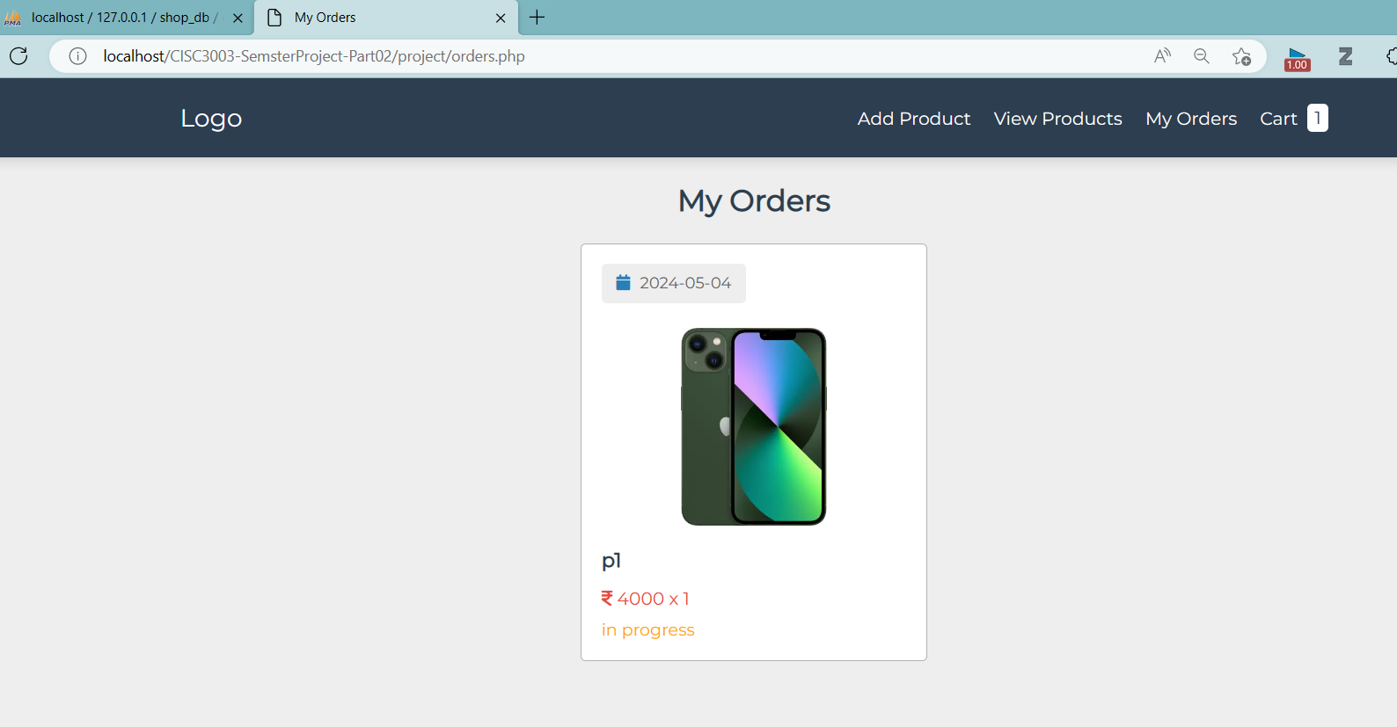

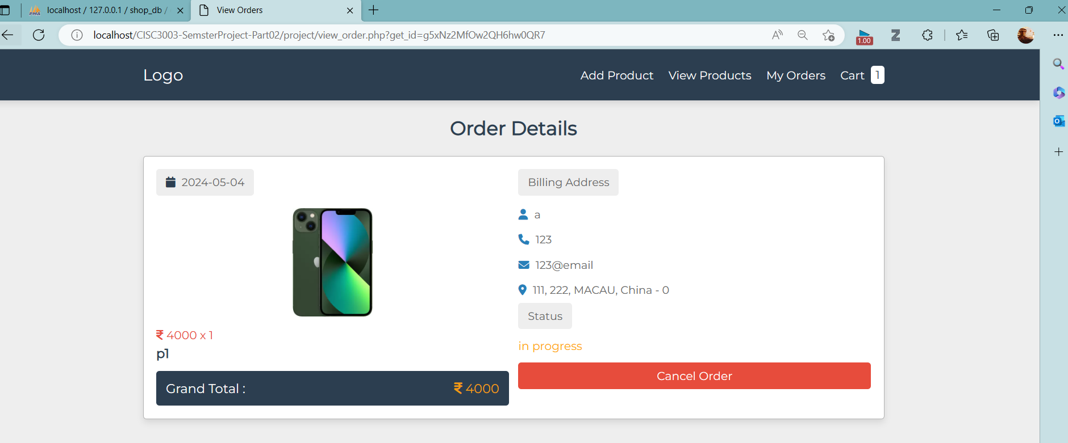

1. The Cart interface shows the user's shopping cart, all the items added to the cart by the user will be shown on this page, the user can adjust the quantity they want to buy here and see the sub total and grand total simultaneously.

The user can adjust the quantity they want to buy and see the sub total and grand total simultaneously. if the user clicks on the delete button at the bottom of the product, the product will be deleted from the cart and the corresponding records in the cart table will be deleted simultaneously.

If the user clicks on the empty cart button at the bottom, the cart will be emptied and all records in the cart table will be cleared.

If the user clicks on the proceed to check out button, the user will be redirected to the Checkout Summary screen to complete the order.

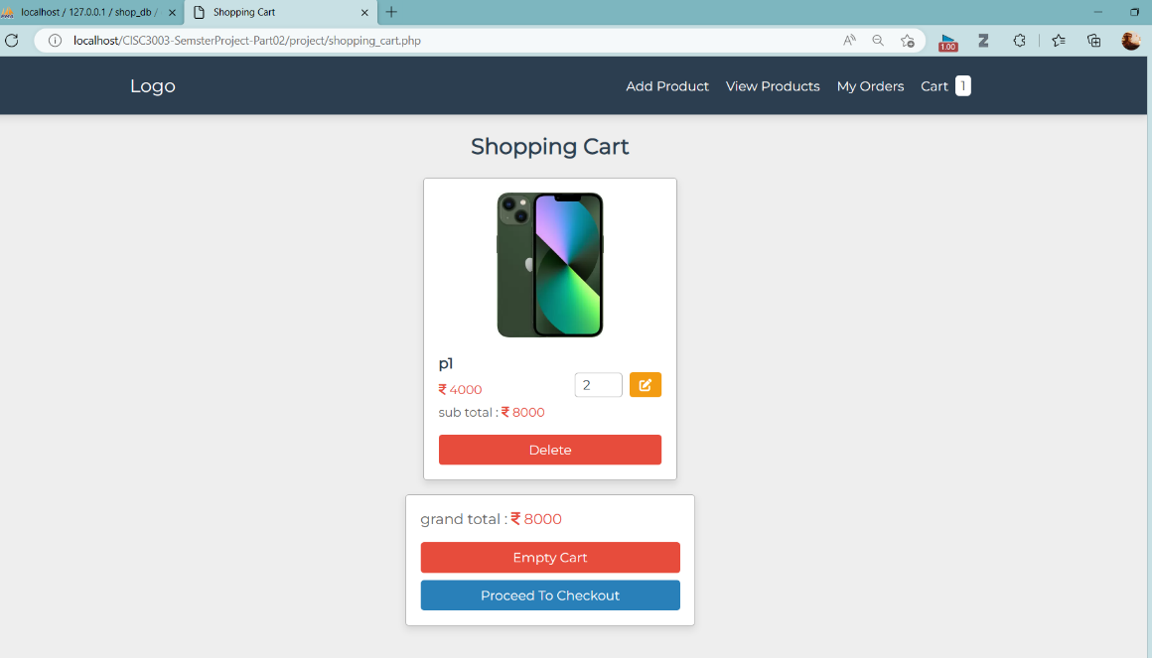

1. Response design: This multi-page website has response design to adapt to different screen sizes.

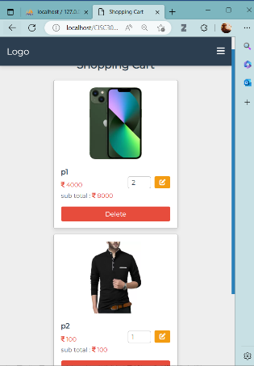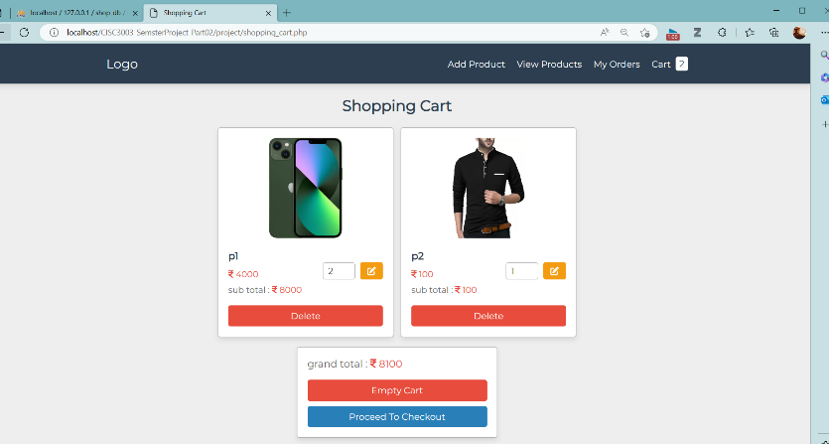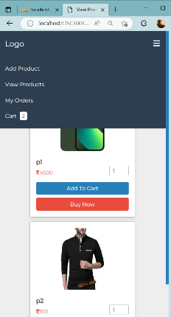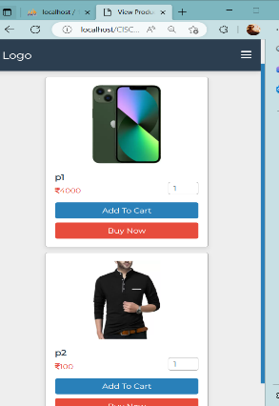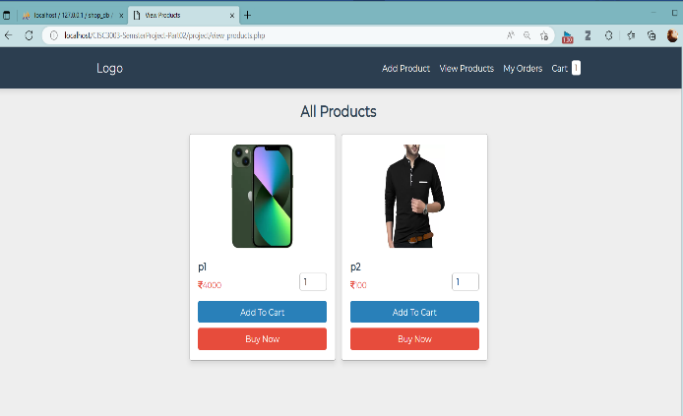When the screen is in a small size, the navigation bar will become a hamburger. And other inline div will become vertically oriented.

